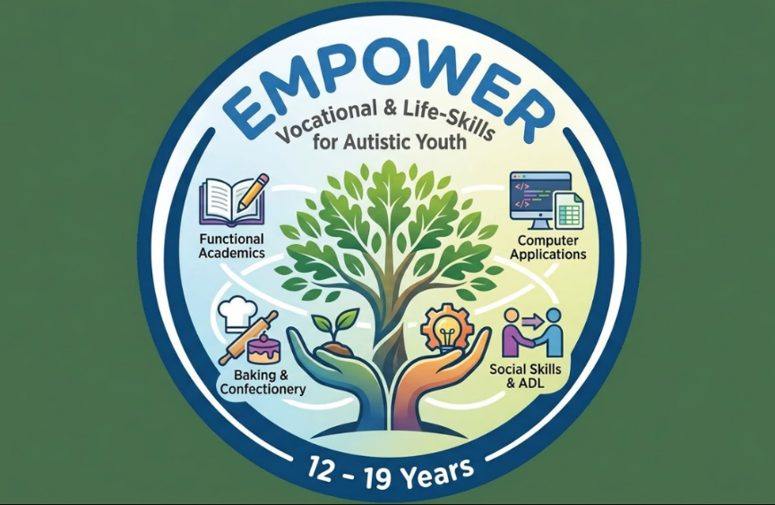
Vocational Training program “EMPOWER” by Creating Links
Our Vocational training program “EMPOWER” believes in empowering autistic youth to an independent adulthood. Our mission is to foster dignity, financial literacy and personal autonomy through evidence based – vocational training.
Through functional academics, we shift the focus from “acquisition” to “application”. We take the skills our children have and turn them into "Life Tools."
From “Abstract” to “Concrete”: instead of teaching just math operations, we teach “Budgeting for a recipe”.
Building a ‘work identity: We work on moving beyond being a "student" to becoming a "baker," "data entry specialist," or "creator."
The Power of Routine: Vocational tasks provide a predictable, sensory-friendly structure that reduces anxiety.
Generalization: Practicing skills in a "real-world" simulation so they can be used at home and in the community.
Program Overview: The "Independence First" Model
The goal of this program is to bridge the gap between school and adulthood. Since we have a 2:1 student-teacher ratio, we can offer highly individualized attention, which is crucial for autism. With a 2:1 student-teacher ratio, errors are corrected immediately, preventing "learned helplessness”. We move at the student’s pace of learning. There will be constant oversight during high-sensory tasks like baking or using technology.
Core Pillars
- Functional Academics: Taught through the lens of the vocational area (e.g., "Math" becomes "Measuring flour for a cake").
- ADL & Personal Safety: Focused on community navigation, hygiene during puberty, and understanding physical boundaries (Crucial for the 12–19 age group).
- Social-Vocational Integration: Teaching students how to work with a peer on a task, rather than just working side-by-side.
Mapping to NIOS Vocational Courses
We are mapping our vocational courses to NIOS standards to ensure that our students earn valid vocational certificates. NIOS offers specific vocational subjects that align perfectly with our chosen areas. By mapping your curriculum to these, your students can earn recognized certificates.

Vocational Area | NIOS Course Code &Name | Equivalence/Level
Baking & Confectionery | Code 256: Bakery and Confectionery | Secondary (Class 10)
Computer Applications | Code 631/632: Certificate in Computer & Office Applications | Vocational Certificate
Educational Aids Making | Code 416-418: Certificate in Toy Making & Joyful Learning | Vocational Certificate
Laundry Services | (Code 255) Laundry Services | Vocational Certificate
Painting | (Code 225/332) Painting | Secondary (Class 10)

Skills targeted in each of the above vocational areas:
Baking & Confectionery (Code 256): Precision, hygiene, and sensory-integrated learning.
Computer Applications (Code 631): Typing, data entry, and digital literacy.
Educational Aids Making (Code 416): Fine motor skills and creative assembly.
Laundry Services (Code 255): A very structured, routine-oriented course that builds high independence in ADLs and professional laundry management
Painting (Code 225/332): While an academic subject, it is highly vocational for students who can sell their art or work in design.
Functional Academics:
For the Functional Academics part, we can enroll them in the NIOS OBE (Open Basic Education) Level A (class 3 equivalent)/Level B (class 5 equivalent)/ Level C (Class 8 equivalent), which allows for flexible subject choices like "Functional Hindi/English" and "Vocational Skills." The placement in Level A, B, C and Secondary will be based on a initial baseline assessment.
Social Interaction:
Activity | Goal | Social Skill
The Two-Person Bake | One student reads the recipe, the other pours | Cooperation & Verbal Cues
The "Help" Protocol | Student A must ask Student B for a tool. | Perspective Taking
The Space Check | Using a "hula hoop" or an arm's length to visualize personal space. | Using Physical Boundaries Personal Safety and Sexuality

Personal Safety & Sexuality Education
We also want our children to navigate life with dignity and safety. So, we have included a personal safety and sexuality education in our curriculum.
Content Points:
- Body Autonomy: Understanding "Public vs. Private" spaces and behaviors.
- The Circle of Trust: Explicitly teaching who can touch whom, and when (Public, Social, and Private circles).
- Puberty & Hygiene: Managing physical changes with specialized social stories and visual schedules.
- Self-Advocacy: Giving students the vocabulary and confidence to say "No" or "I am uncomfortable."
Curriculum Structure: The Daily Flow
To keep students engaged, a "Flow State" schedule works best for neurodivergent learners:
- Morning Circle (30 mins): Social interaction, calendar skills, and daily goal setting.
- Functional Academics (1 hour): Literacy and Math related to their specific vocational track.
- Vocational Block 1 (1 hour): Hands-on work in Baking, Computers, or Aid making.
- ADL & Life Skills (45 mins): Personal grooming, sexuality education (using social stories), and snack prep.
- Peer Social Hour (45 mins): Collaborative games or group projects.
Fee structure
We offer two models for our vocational training program
Model 1 (4-hour): "Vocational Core"
4-hour engagement model(e.g., 10 AM – 2 PM) focusing on Vocational +Functional Academics + ADL + Social Skills.
  - Monthly Tuition: [Insert Range, e.g., ₹18,000 – ₹22,000]
  - Material Fee: [Insert amount] (Covers all baking supplies and tech tools).
  - Next Steps: Intake assessment and IEP (Individualized Education Program) goal setting.

Model 2 (6-hour): "Academic Plus"
Full day engagement model (e.g., 10 AM – 4 PM) focusing on Vocational + Functional Academics+ ADL + Social Skills+ Academics (NIOS curriculum)
  - Monthly Tuition: [Insert Range, e.g., ₹22,000 – ₹26,000]
  - Material Fee: [Insert amount] (Covers all baking supplies and tech tools).
  - Next Steps: Intake assessment and IEP (Individualized Education Program) goal setting

SUBJECTS OVERVIEW
Here is an overview of the five vocational subjects we have selected. These courses are highly compatible with the "EMPOWER" program because they rely on structured routines, visual patterns, and tangible results.
1. Bakery and Confectionery (Code 256)
This is a high-structure, sequence-based course. For students with autism, the predictability of recipes provides a comforting and functional routine.
- Core Content: Identification and use of bakery equipment, study of ingredients (flour, sugar, fats, leavening agents), and the science of baking.
- Practical Skills: Preparing various types of breads, biscuits, cookies, cakes, pastries, and basic icing techniques. It also emphasizes hygiene, sanitation, and commercial packaging.
- Vocational Outcome: Training to work in commercial bakeries, hotel kitchens, or setting up a micro-enterprise/home-based baking business.
2. Computer & Office Applications (Code 631/632)
This track leverages the "systemizing" strengths often found in neurodivergent individuals, focusing on accuracy and digital organization.
- Core Content: Basics of computer hardware and software, operating systems (Windows), and file management.
- Practical Skills: Mastery of MS Word (creating documents, letters, and resumes), MS Excel (data entry, spreadsheets, and basic formulas), and MS PowerPoint (creating presentations).
- Vocational Outcome: Preparation for roles in data entry, office administration, or digital content organization.
3. Toy Making & Joyful Learning (Code 416-418)
This maps perfectly to your "Educational Aids Making" track. It is a creative yet structured course that results in physical products used in early childhood education.
- Core Content: Understanding the importance of play in learning, selecting safe and durable materials, and the aesthetics of toy design.
- Practical Skills: Making soft toys, wooden blocks, puzzles, and flashcards. It involves cutting, sticking, stitching, and assembling educational kits.
- Vocational Outcome: Working in toy manufacturing units, creating teaching aids for playgroups/schools, or starting a craft-based social enterprise.
4. Laundry Services (Code 255)
Laundry is a "High-Frequency" Life Skill. It is highly predictable and follows a clear step-by-step process, making it an excellent vocational and ADL (Activities of Daily Living) hybrid.
- Core Content: Knowledge of different fabrics (cotton, wool, silk), understanding detergents/chemicals, and the mechanics of washing machines and dryers.
- Practical Skills: Sorting clothes by color/fabric, stain removal, washing, drying, folding, and professional ironing (pressing).
- Vocational Outcome: Gaining employment in hospital or hotel laundries, or managing independent laundry services for the community.
Painting (Code 225/332)
While often seen as "art," in a vocational context, this focuses on technical precision, color theory, and the production of marketable goods.
- Core Content: Study of mediums (oil, water, acrylic), color mixing, and composition.
- Practical Skills: Creating still life, landscapes, and traditional folk art. It also includes the "presentation" aspect—mounting and framing.
- Vocational Outcome: Opportunities in graphic design assistance, professional art production, or selling products through "Art Therapy" or "Neurodiverse Artist" platforms.

Strategic Mapping of our Program:
- For the "Foundation Track" (4-hour): Focus on the Practical Skills of these courses to build functional independence and "Work Identity."
- For the "Comprehensive Track" (6-hour): Include the Theory and Documentation aspects of these NIOS codes to prepare students for the actual NIOS certification exams.

NIOS Secondary – Class 10 Certification
For the NIOS Secondary (Class 10) Certification, there are specific rules about how you can mix academic and vocational subjects. Since you are building the "EMPOWER" program, understanding this flexibility is key for your students' certification paths.
Here is the breakdown of the subject requirements:
1. The "5-Subject" Rule for Certification
To obtain a Secondary School Certificate, a student must pass a minimum of five subjects in total.
- Minimum 1 Language: A student must take at least one language (e.g., English or Hindi).
- Maximum 2 Languages: Only two languages can be counted toward the five subjects required for certification.
- The Mix: The remaining subjects (3 or 4) can be a combination of Academic subjects and Vocational subjects.
2. How many Vocational Subjects can you take?
NIOS is very flexible regarding vocational integration:
- Standard Route: Most students take one or two vocational subjects alongside core academic subjects like Home Science, Data Entry Operations, or Painting.
- Vocational Route: You can actually take up to four vocational subjects to complete the five required for the certificate, as long as you have at least one language.
3. Strategic Selection for "EMPOWER" Students
For students with autism, it is often beneficial to choose subjects that have a high Practical-to-Theory ratio. For example, a student could certify in Class 10 by taking:
- Language: English (Code 202)
- Academic/Practical: Painting (Code 225) — 70% Practical
- Academic/Practical: Data Entry Operations (Code 229) — 60% Practical
- Vocational: Bakery & Confectionery (Code 256) — 60% Practical
- Vocational: Laundry Services (Code 255) — 60% Practical
4. Important Limitation: Groups
When selecting subjects, you must ensure they are not from the same "Group" if they have overlapping exam times. However, for the subjects you selected (Bakery, Painting, Computers, Laundry), they generally fall into different categories, allowing you to bundle them together for a single student.
5. Stand-alone Vocational Certificates
If a student is not aiming for a full Class 10 "Pass Certificate" but rather specific job skills, they can take any number of vocational subjects as "Stand-alone" courses. They will receive a separate certificate for each vocational course they pass (e.g., a Certificate in Toy Making), even if they do not complete the Academic/Language requirements.

"Empowerment is not just about teaching a skill; it is about building the bridge between a child’s potential and an adult’s independence."

In EMPOWER, we don't just teach tasks; we cultivate identities. We turn students into bakers, creators, and citizens."

Dear Parents and Caregivers,
Welcome to EMPOWER, a specialized vocational and life-skills initiative by Creating Links.
As educators and parents, we often find ourselves asking: “What happens next?” When our children move into the critical transition years of 12 to 24, the goal of education must evolve. It is no longer just about acquiring facts; it is about cultivating independence and a sense of belonging in the adult world.
At EMPOWER, we believe that:
"We don't just teach tasks; we cultivate identities. We turn students into bakers, creators, and citizens."
Our program is built on the "Independence First" model. With a 2:1 student-teacher ratio, we provide the intensive, individualized support necessary to bridge the gap between school and a purposeful adulthood. Whether it is mastering the precision of a bakery kitchen, navigating the digital landscape of computer applications, or understanding the complexities of personal safety and social interactions, every activity is designed to turn "potential" into "competence."
We invite you to partner with us on this journey. Together, we can help our young adults move beyond the label of "student" and step into their roles as confident, skilled, and empowered individuals.
With warmth and dedication,
Creating Links Team

